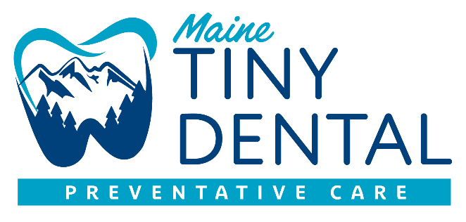

**INFORMED CONSENT FOR SILVER DIAMIDE FLOURIDE (SDF)**

**Benefits of receiving SDF:**

*SDF can help stop tooth decay

*SDF can help relieve tooth sensitivity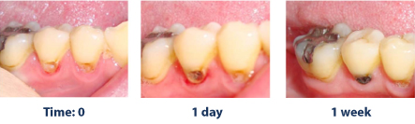

**Risks related to SDF include, but are not limited to:**

\***The affected area will stain black permanently.** Healthy tooth structure will not stain. Stained tooth structure can be replaced with a filling or crown.

*Tooth colored fillings and crowns may also discolor if SDF is applied to them. Normally in these areas the color change is temporary and can be polished off.

*If accidentally applied to the skin or gums, a brown stain may appear that causes no harm, cannot be washed off, and will disappear in 1-3 weeks.

*You may notice a metallic taste. This will go away rapidly.

*If tooth decay is not arrested, the decay will progress. In that case the tooth will require further treatment, such as repeat SDF, a filling, crown, root canal treatment or extraction.

*These side effects may not include all the possible situations reported by the manufacturer. If you notice other effects, please contact your dental provider.

*Every responsible effort will be made to ensure the success of SDF treatment. There is a risk that the procedure will not stop the decay and no guarantee of success is granted or implied.

**Alternatives to SDF, not limited to the following:**

*No treatment, which may lead to continued deterioration of tooth structures and cosmetic appearance. Symptoms may increase severely.

*Depending on the location and extent of the tooth decay, other treatment may include placement of fluoride varnish, temporary fillings. Patients will be referred to dentists or specialist as needed.

**I CERTIFY THAT I HAVE READ AND FULLY UNDERSTAND THIS DOCUMENT. AND ALL MY QUESTIONS WERE ANSWERED.**

**_________________________Patients Name**

**_________________________Patient or guardian signature**

**_________________________Date**