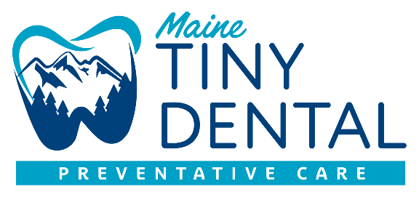

**CONSENT FOR NON-SURGICAL GUM THERAPY (SCRP)**

**Area or areas of the mouth which treatment is being recommended:**

**__________________________________________________________________**

The purpose of this document is to provide written information regarding the risks, benefits, and alternatives to the procedure named above. This material serves as a supplement to the discussion you have had with your provider at Maine Tiny Dental. It is important that you fully understand, so please read this document thoroughly. If you have any questions regarding the procedure, please ask prior to signing the consent form.

**THE PROCEDURE**

Non-surgical gum therapy also known as scaling and root planning is the removal of calculus (tartar), bacterial plaque, and toxins from above and below the gumline. This procedure is performed by a registered dental hygienist. The hygienist will use various tools including hand instruments, ultrasonic scaler, and air polisher to loosen and remove the bacterial debris above and below the gumline. You have the option to use a topical anesthetic to make the procedure more comfortable if needed. If your provider feels you may need a local anesthetic a plan will be made to have this completed by your provider or another hygienist within a dental office setting, where a dentist is present. Local anesthesia is an injection of a numbing agent to relieve pain and make the procedure more comfortable.

**RISKS**

I have been informed of and understand the potential risks related to this procedure include but are not limited to:

*Varying lengths and degrees of sensitivity.

*Swelling, sensitivity, and/or bleeding of gum tissue.

*Infection of the teeth, gum tissue, or bone.

*Increased spacing between teeth due to removal of hard deposits.

*Revealing recessed gums which can cause prolonged sensitivity. However, there are desensitizing agents that we can utilize to minimize this.

*Cracking or stretching of the lips or corners of the mouth. This is temporary after the procedure.

*Increased mobility of teeth, if deemed severe enough a referral will be made to specialist. This is due in part to the amount of bone loss present.

*Allergic and or adverse reaction to anesthetic, medication or materials

**My provider will discuss my personal risks prior to my appointment.**

**BENEFITS**

It has been explained to me that the purpose of this therapy is to reduce some of the causes and symptoms of active periodontal disease. I understand that although there is no cure for periodontal disease, it can be treated and managed. I understand my condition may require additional treatment that may include additional deep cleanings, periodontal surgery, laser therapy, and or use of oral or topical antibiotics.

**ALTERNATIVES**

Once periodontal disease has progressed to the point of needing non-surgical gum therapy or more advanced periodontal therapies. There are no advisable alternatives. Dependent on the level of disease, it may be possible to continue hygiene visits with the understanding that the progression of the disease is inevitable, and loss of tissue attachment and bone loss will continue. Bacteria and toxins will continue to stay below the gumline and cause harm to the surrounding tissue and supporting bone. There is also a risk of health complications related to this type of bacteria not being removed.

**POST TREATMENT**

I agree to follow all instructions provided to me by my provider at Maine Tiny Dental. These instructions include:

*Taking over the counter pain medications as needed.

*Informing my provider and Maine Tiny Dental of any post-operative problems if they arise.

*My failure to comply with recommended recall appointments could result in complications or less than optimal results.

*I understand that if my condition does not improve, I will be referred to a periodontist to discuss further treatment options.

*Using an antimicrobial rinse once daily for 5-7 days post procedure.

*I understand that non-surgical gum therapy is only the first step in managing my periodontal disease. I must follow the instructions for frequency of dental visits and homecare to stabilize and optimistically arrest the disease.

*I understand that I may need to have this procedure done more than one time if my condition does not improve.

**CONSENT**

By signing below, I attest that my provider and Maine Tiny Dental have explained the treatment/procedure to me. They have explained how this can help and manage my disease, they have also discussed the risks and complications. My provider has discussed what could happen if I were to decline this procedure. I understand that neither the provider nor Maine Tiny Dental can guarantee the success and results of the procedure and no guarantees have been made to me. My provider has answered all my questions. I know that I may refuse or change my mind about this procedure. I also understand that dependent on my level of disease and contributing health factors my provider may refuse to treat me due to risks associated with neglecting the disease.

**Patients name:**

**Patients signature:**

**Providers signature:**